Name：SINALO APLENI
Phone：0655580065
Email：sinaloapleni2@gmail.com
Date of Assessment: 23 June 2025

MedDelivery App

Software Requirements Specification (SRS)

Project Name: MedDelivery App
Document Creation Date: 23 June 2025
Version Number: 1.1

1. Introduction
The MedDelivery app is a mobile and web-based application designed to facilitate medication ordering, delivery, and communication between clinics, patients, and delivery teams. The app caters to diverse demographics, including older adults, adults, and children with chronic health conditions such as diabetes, hypertension, or asthma, living in urban or rural areas with internet and mobile device access.
Scope: The app will enable patients to order medication, track orders, and receive reminders. Clinics will manage orders,track deliveries, and communicate with patients. Delivery teams will receive delivery orders, manage deliveries, and confirm deliveries.

2. Purpose and Scope
Purpose: The MedDelivery App aims to provide a convenient and efficient way for patients to order medication and for clinics to manage medication orders and deliveries.
Scope: The solution includes three main modules: Patient Mobile App, Clinic Web Portal, and Delivery Team App. It also includes secure backend services and cloud-based databases.

3. Functional Requirements
Patient Module:
- Order medication
- Track orders
- Receive delivery reminders
- View medication history
Clinic Module:
- Approve and manage patient orders
- Track order status and inventory
- Communicate with patients
Delivery Team Module:
- Receive delivery orders and manages deliveries
- Update delivery status
- Confirm medication delivery
Use Cases:
- Patient places an order
- Clinic processes and approves orders
- Delivery team delivers medication

4. Non-Functional Requirements
- Performance: App response time should be under 2 seconds.
- Security: Encrypted communication and secure authentication.
- Reliability: Ensure 99.9% uptime.
- Compatibility: Support for Android, iOS, Chrome, Firefox.
- Usability: User-friendly interface
- Scalability: Must handle up to 10,000 users.

5. User Requirements
- Patients: Simple mobile interface for ordering and tracking
- Clinics: Efficient interface for clinics to manage orders.
- Delivery Teams: Simple interface for delivery teams to manage deliveries.
- Administrators: Backend tools for managing system-wide settings

6. System Architecture
High-Level Architecture: The app will consist of a patient module, clinic module, delivery team module, and database.
Components: Patient app, clinic web portal, delivery team app, database.
Interactions: Patient app interacts with clinic web portal and delivery team app.
Data Requirements:-
Patient Information: Store patient information, including name, address, and medication history.
Order Details: Store order details, including medication name, dosage, and delivery address.
Delivery Status: Store delivery status updates.

7. Data Requirements
- Patient Information: Name, contact, address, medical history
- Orders: Medication name, dosage, status, timestamps
- Delivery: Assigned driver, timestamps, GPS location, confirmation status

8. Assumptions and Constraints
- Patients own smartphones and have internet access.
- Clinics update medication inventory in real time.
- Constraints: Delivery capacity, app permissions, data privacy laws.

Dependencies
- Cloud services (e.g., Firebase, AWS)
- Mobile OS and browser compatibility

10. Risk and Mitigations
Risk: Data security breaches.
Mitigation: Implement robust security measures, including encryption and secure data storage.

11.Traceability Matrix
-Mapping: Map each requirement to its corresponding design and testing artifacts.

12. Approval and Sign-off
- Stakeholders: Patients, Clinic Admins, Delivery Managers
- All stakeholders must sign off before the development phase begins.

Pseudocode for MedDelivery App:

Patient Orders Medication
1. Patient logs in to the app.
2. Patient selects the medication and dosage.
3. Patient enters the delivery address.
4. Patient confirms the order.
5. App sends the order to the clinic.
6. App updates the order status.

Clinic Manages Orders
1. Clinic staff log in to the app.
2. Clinic staff view the orders.
3. Clinic staff prepare the medication.
4. Clinic staff dispatch the medication.
5. App updates the order status.

Delivery Team Manages Deliveries
1. Delivery team logs in to the app.
2. Delivery team views the delivery orders.
3. Delivery team updates the delivery status.
4. Delivery team confirms the delivery.

Patient Tracks Order
1. Patient logs in to the app.
2. Patient views the order status.
3. Patient tracks the delivery.

CLASS MedDeliveryApp
METHOD Main()
WHILE TRUE
DISPLAY "MedDelivery App"
DISPLAY "1. Register Patient"
DISPLAY "2. Place Order"
DISPLAY "3. Update Order Status"
DISPLAY "4. Track Order"
DISPLAY "5. Generate Report"
DISPLAY "6. Exit"
GET userInput
SWITCH userInput
CASE 1:
CALL RegisterPatient()
CASE 2:
CALL PlaceOrder()
CASE 3:
CALL UpdateOrderStatus()
CASE 4:
CALL TrackOrder()
CASE 5:
CALL GenerateReport()
CASE 6:
EXIT
DEFAULT:
DISPLAY "Invalid choice"
END SWITCH
END WHILE
END METHOD
METHOD RegisterPatient()
DISPLAY "Enter patient name:"
GET patientName
DISPLAY "Enter patient address:"
GET patientAddress
CREATE Patient(patientName, patientAddress)
DISPLAY "Patient registered successfully!"
END METHOD
METHOD PlaceOrder()
DISPLAY "Enter patient ID:"
GET patientId
DISPLAY "Enter medication name:"
GET medicationName
DISPLAY "Enter quantity:"
GET quantity
CREATE Order(patientId, medicationName, quantity)
DISPLAY "Order placed successfully!"
END METHOD
METHOD UpdateOrderStatus()
DISPLAY "Enter order ID:"
GET orderId
DISPLAY "Enter new status:"
GET newStatus
UPDATE Order(orderId, newStatus)
DISPLAY "Order status updated successfully!"
END METHOD
METHOD TrackOrder()
DISPLAY "Enter order ID:"
GET orderId
DISPLAY "Order status: " + GET OrderStatus(orderId)
END METHOD
METHOD GenerateReport()
DISPLAY "Orders:"
FOREACH Order IN orders
DISPLAY "Order ID: " + Order.OrderId
DISPLAY "Patient ID: " + Order.PatientId
DISPLAY "Medication name: " + Order.MedicationName
DISPLAY "Quantity: " + Order.Quantity
DISPLAY "Status: " + Order.Status
END FOREACH
END METHOD
END CLASS

Login and Register
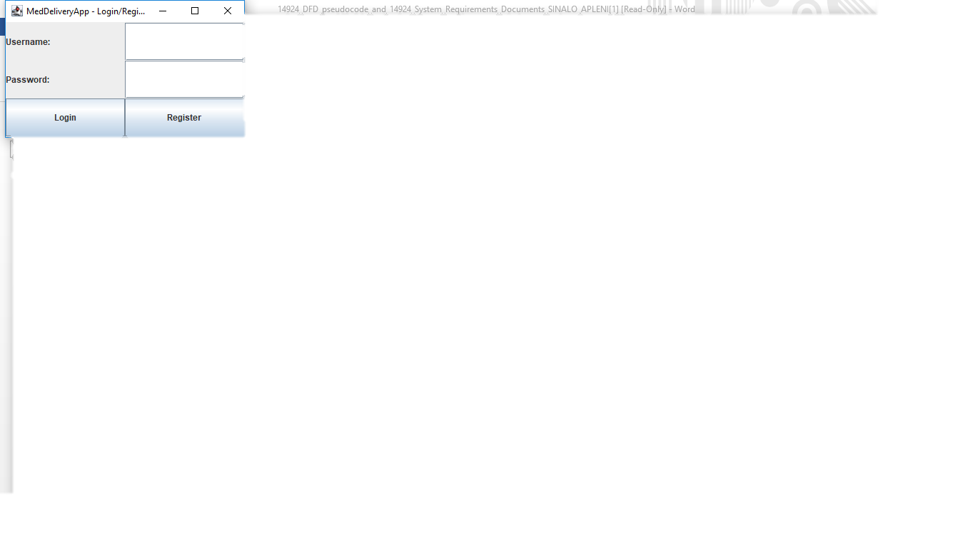
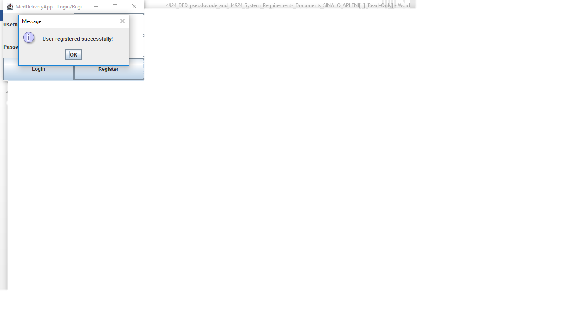

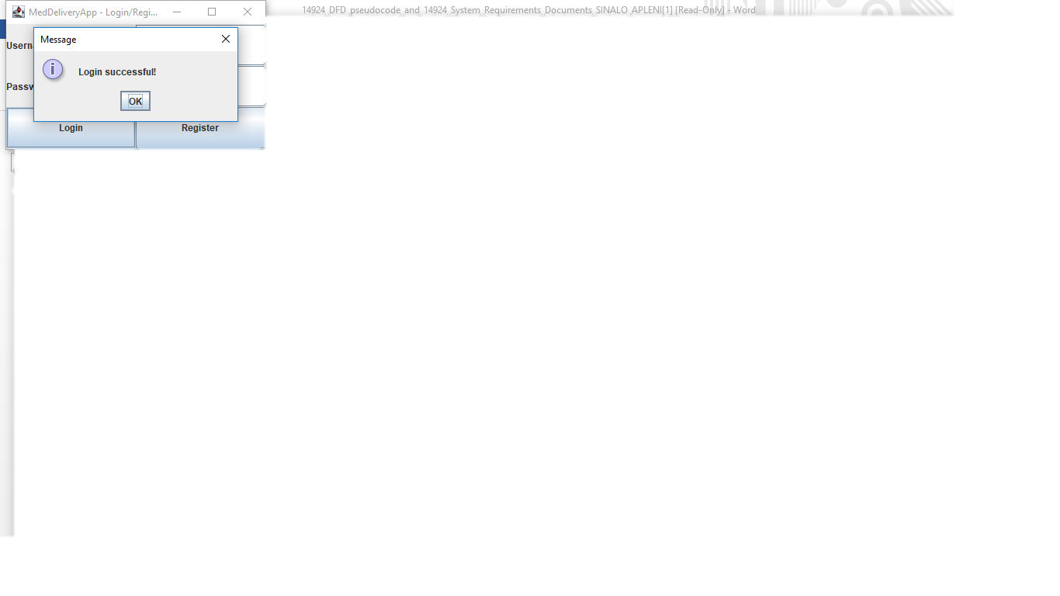

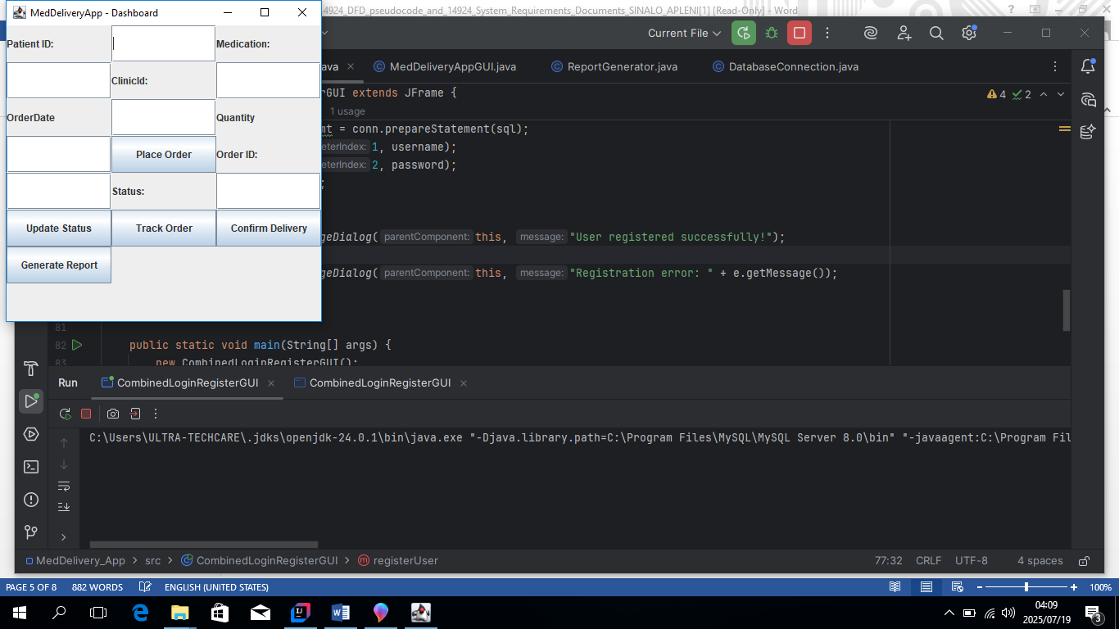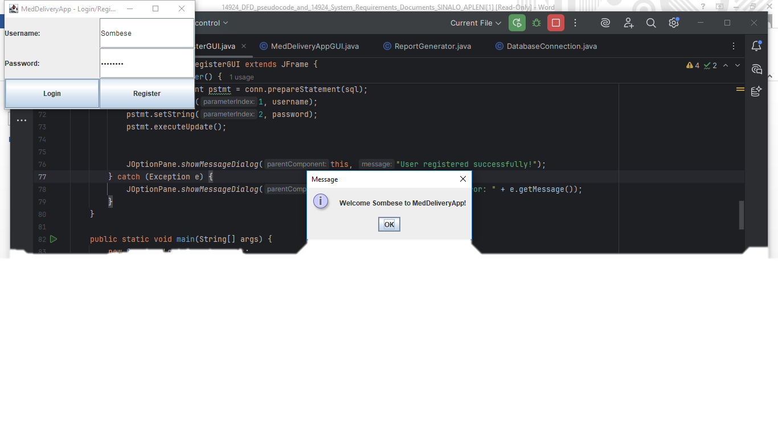
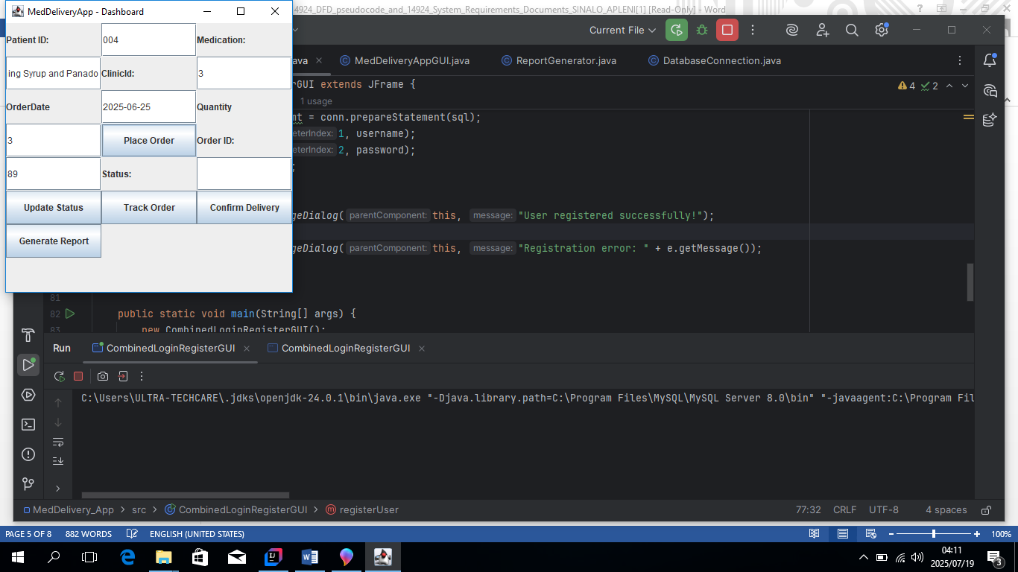

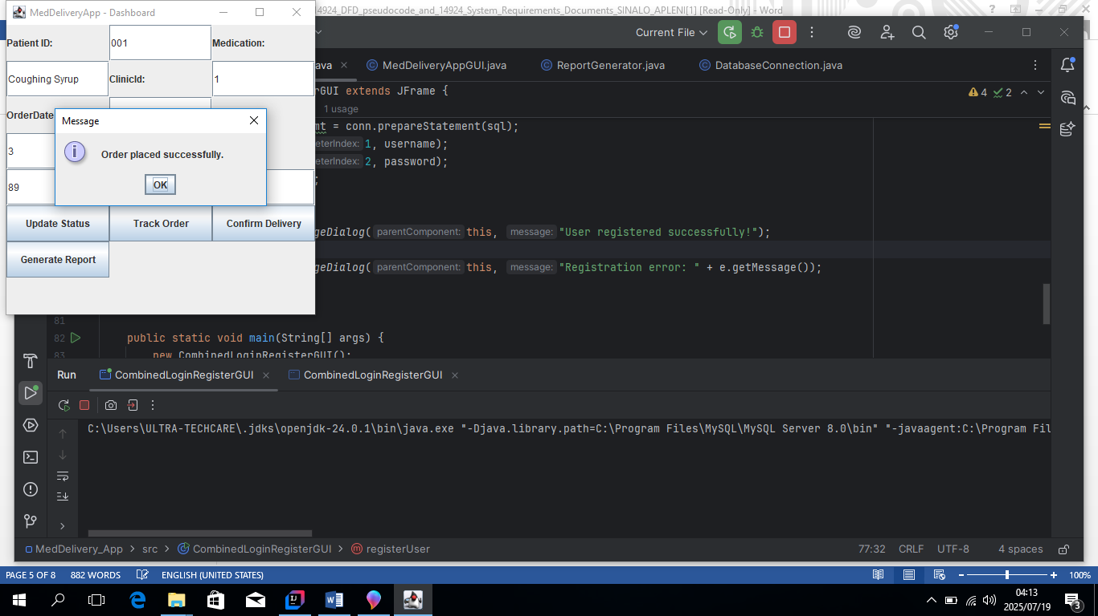

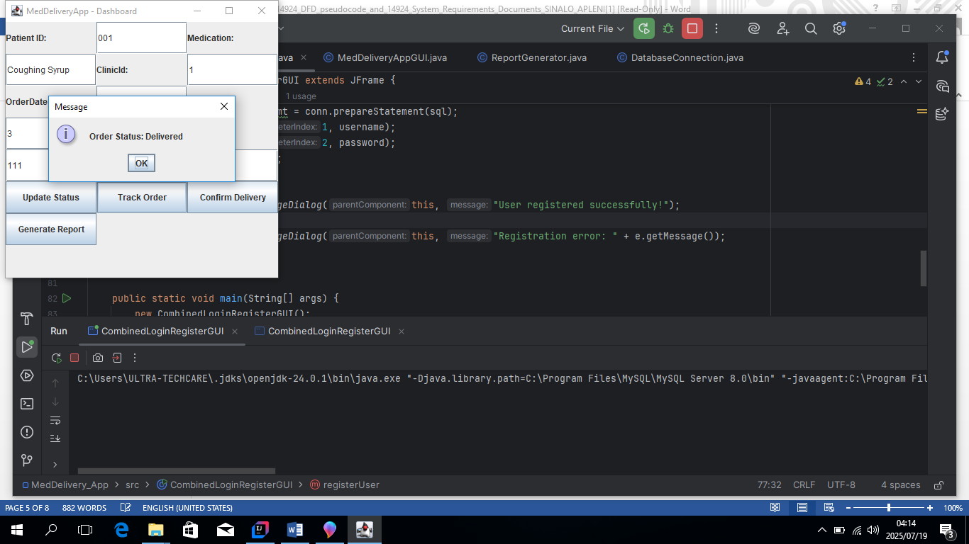

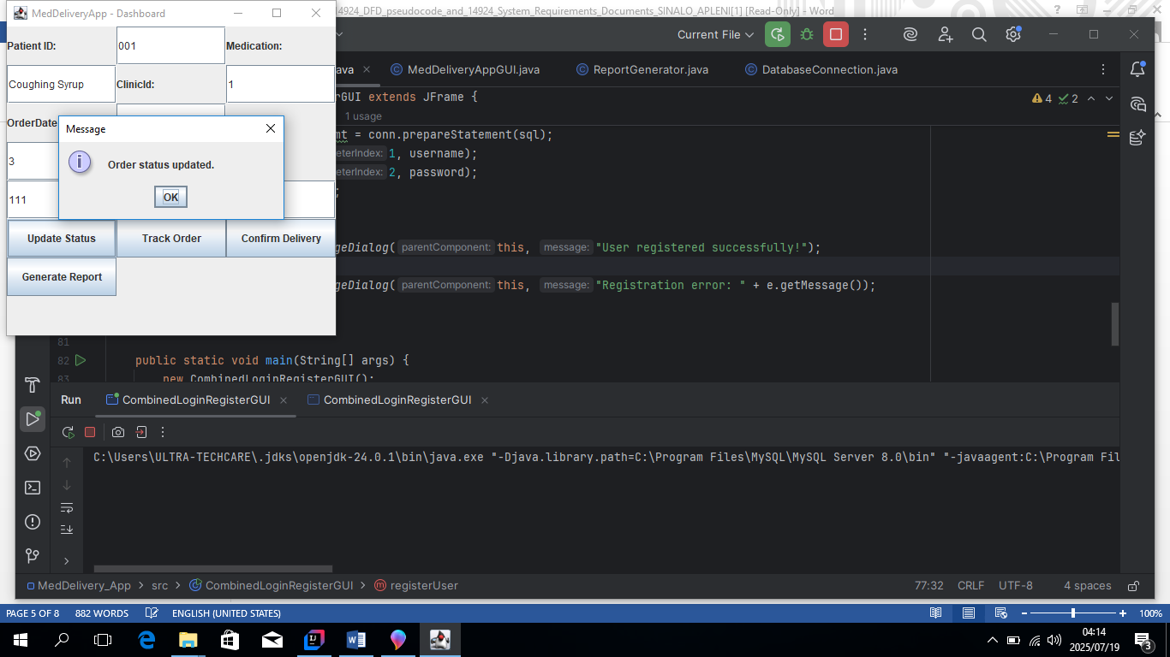

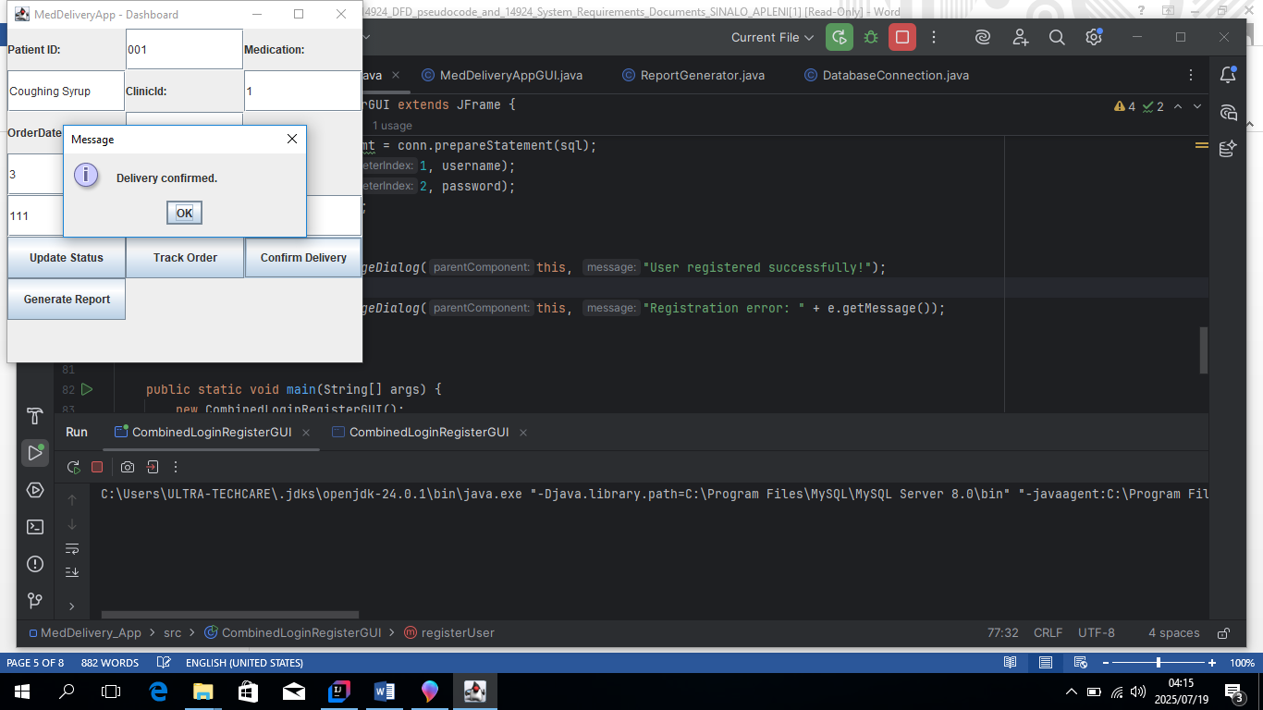

DFD for MedDelivery App:

